

OPTIMZATION OF TAPROOT FIBRE MANUFACTURING USING

AVAILABLE RESOURCES

Prepared For: Dr. Scott Flemming

Prepared by:
JAFIR SULAIMAN SATHATH ALI (B00989993)

Table of Contents
Introduction 2
Background 2
Workbench 2
Breaker: 3
Scutching Machine 3
Button 4
PROBLEM STATEMENT 7
Our Model 8
ONE WORKER AND 2 CLIPS(JOBS) 9
ONE worker and 3 clips 10
ONE WORKER AND 4 CLIPS 11
ONE WORKER AND FIVE CLIPS(JOBS) 12
ONE WORKER AND SIX CLIPS(JOBS) 13
Finding Optimum clips(jobs) with available resource. 14
Improvement (without increasing available resources) 15
ONE WORKER AND 2 CLIPS(JOBS) 17
ONE WORKER AND 3 CLIPS(JOBS) 17
ONE WORKER AND 4 CLIPS(JOBS) 18
ONE WORKER AND 5 CLIPS(JOBS) 18
ONE WORKER AND 6 CLIPS(JOBS) 19
Finding Optimum clips(jobs) with available resource after improvements 20
Future study and suggestion 21
Conclusion 22
Acknowledgement 22

Introduction
The main focus on this project is to improve the scutching process at TapRoot farms. Before explaining the method used we will describe the production process in more detail.

Background
Flax is a natural agricultural product. It has to undergo sequence of many tasks to get a final output of long-line linen fibre. Long-line can be converted to make various textiles. It is a an industry that is growing steadily due to increasing demand for natural fibres which are eco-friendly.

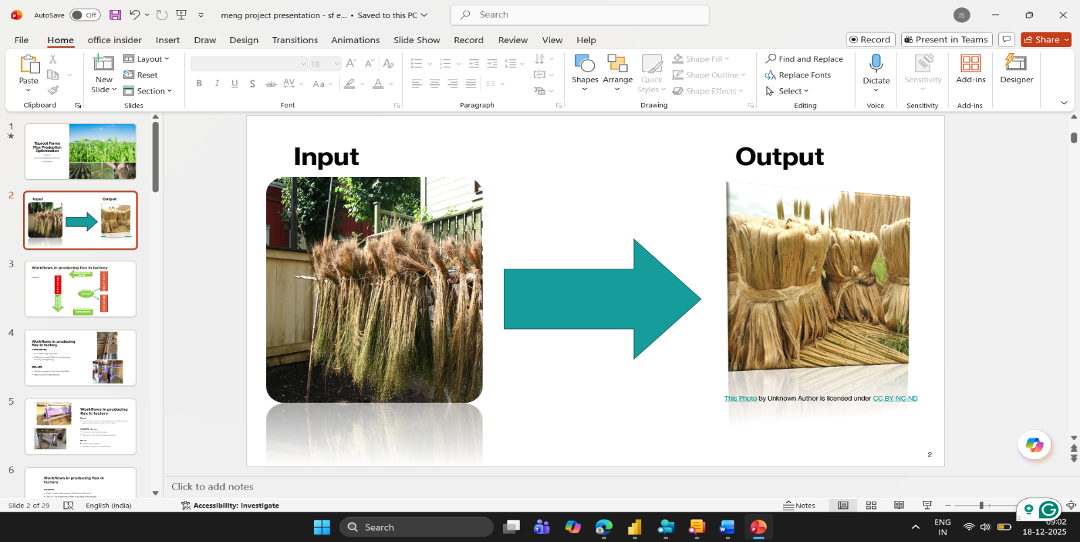

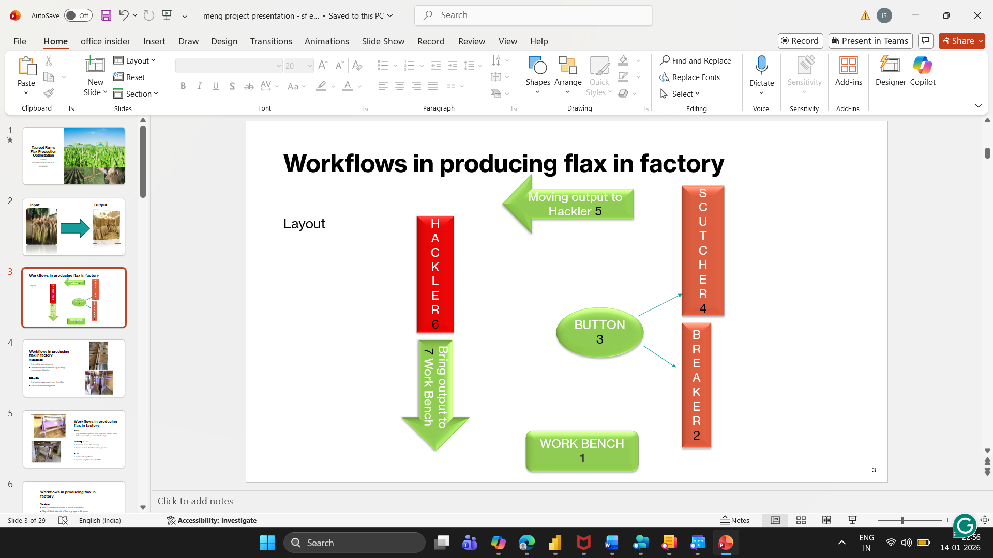

Workbench
It is a initial stage of process where worker rests the plant fibre on the table.Here ,worker attaches the fibre in a clip and screw it up firmly for process.Clip which helps to hold fibre very effectively.Second time,we have to uncrew clip in this workbench.After that, we have to flip it other side of fibre and start screw it in that clip.

Breaker:
In that factory ,there are three machines.Breaker is one of the machine. It is located near to workbench and Scutching machine.It helps to separate woody layer from fibre.Make it even better for futher process.Literally,it breaks hard layer of the root.
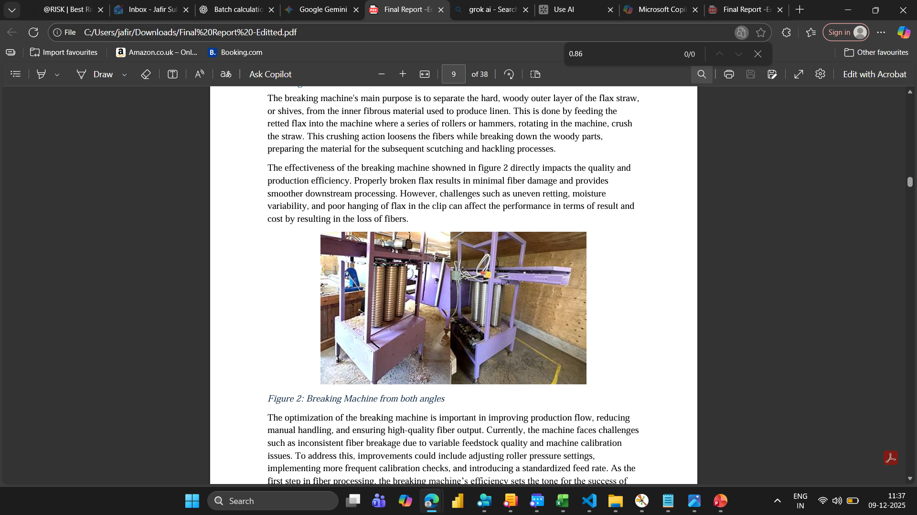
Figure 1: Breaker machine at TapRoot Farms

Scutching Machine
It removes shives after breaking and helps to clean fibre for hackling process.

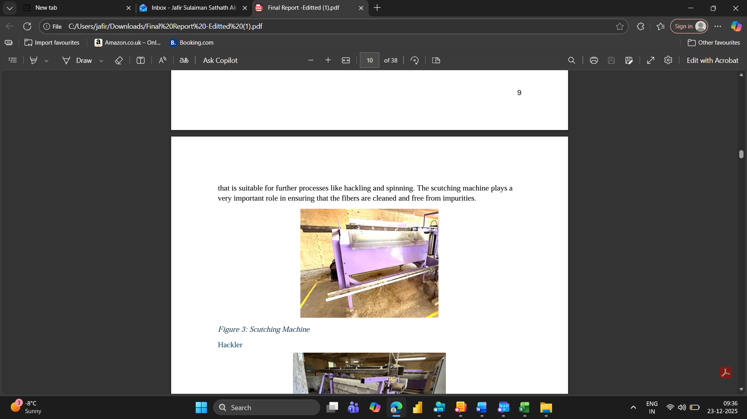
Scutching Machine.

Button
Clip automatically moves from breaker to scutcher after a button is pressed to go to the 2nd of 3 steps.

.

Flax is fixed in the clip which helps to carry the flax firmly all through the process.Clip has to go two through twice because it has to be flipped upside down after the first time.


Fibre is attached to the clip

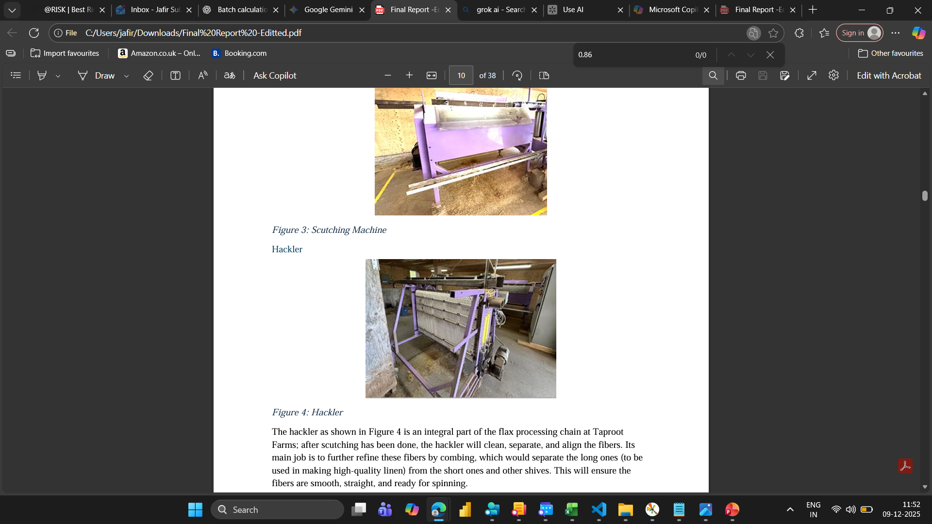
Hackler
It Combs and align fibres and separates long fibre from short fibre.

Table 1: Machine and Task processing times
Note: P1(A),P7(A) ,P2(B) and P7(B) which are workbench process time , split into two processing time for priotiozing machine works and other short processing time in other clips

Tasks | Sequence | Processing time(minutes)
Workbench | P1(A) | 2.2
Workbench | P1(B) | 0
Breaker | P2 | 1.34
Button | P3 | 0.17
Sctuching machine | P4 | 0.77
Moving output to hackler | P5 | 1.2
hackler | P6 | 2
Workbench | P7(A) | 2.25
Workbench | P7(B) | 0
breaker | P8 | 1.34
Button | P9 | 0.17
Scutching machine | P10 | 0.77
Moving output to hackler | P11 | 1.2
hackler | P12 | 2
workbench | P13 | 2.25

PROBLEM STATEMENT
For this project, we wished to find out what number of clips would result in the greatest production in terms of grams of long-line linen produced. In this project we assumed the following:
- One breaker
- One sctuching machine
- One work bench
- Single worker
In order to find out how the number of clips affected the total output we used an LP that calculated the makespan when a given number of clips was used. We used a video of the process to estimate the processing times for each part of the process.

.

Our Model
Objectives :
- Min Cmax
Constraints:
Precedence Constraints:
- S_{I+1} > =C_{I}
- S_{J}>=C_{I+1}
Avoiding Overlap human work in one clip with other clip
- C_{J} – S_{I+1}- BIG M NUMBER*(1- P_{J})<=0
- C_{I+1} -S_{J} - BIG M NUMBER*(1- P_{I})<=0
(Likewise we have to do it for all human process)
- P1(A)+P1(B)=2.2
- P7(A)+P7(B)=2.25
- P_{I}+P_{J}=1
- Human completion time= starting time of machine
- Decision Variable are all starting time (S) of process and human processing time for workbench(P1(A),P1(B),P7(A) and P7(B) )which are divided into two parts to stop and pause after prioritize other short processing time.
- C denotes completion time.
- P denotes processing time.
- P1,P3,P5,P7,P9,P11,P13 – This process is done by worker
- P2,P4,P6,P10,P12- This processes are machine.
Using this model, we get gantt chart.

ONE WORKER AND 2 CLIPS(JOBS)
CMAX:20.7
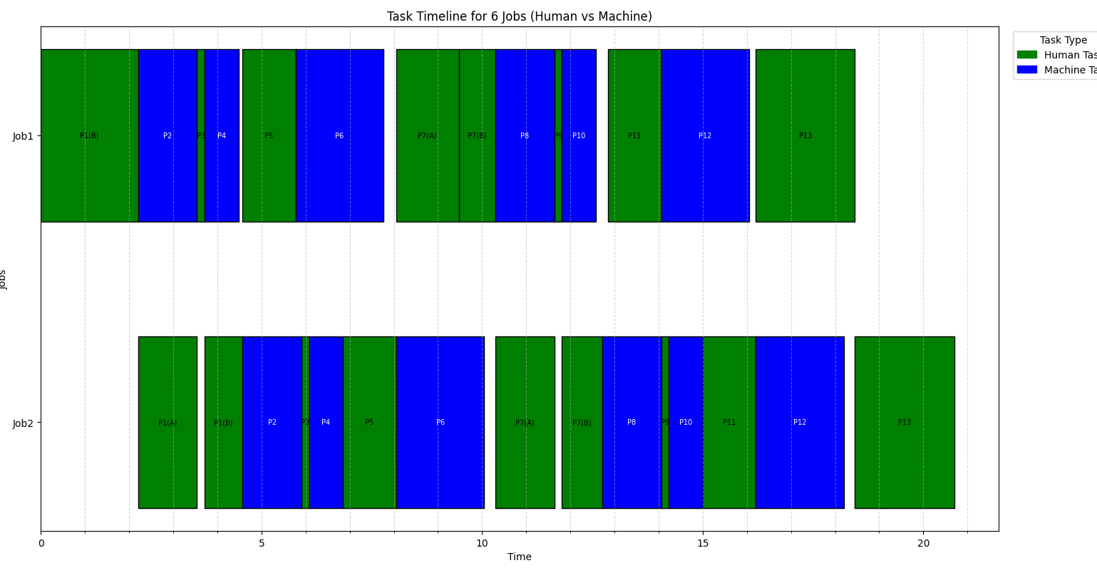

ONE worker and 3 clips
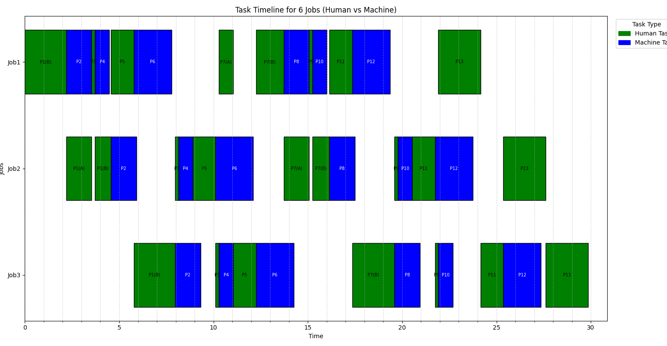
CMAX:29.86

ONE WORKER AND 4 CLIPS
CMAX:29.86
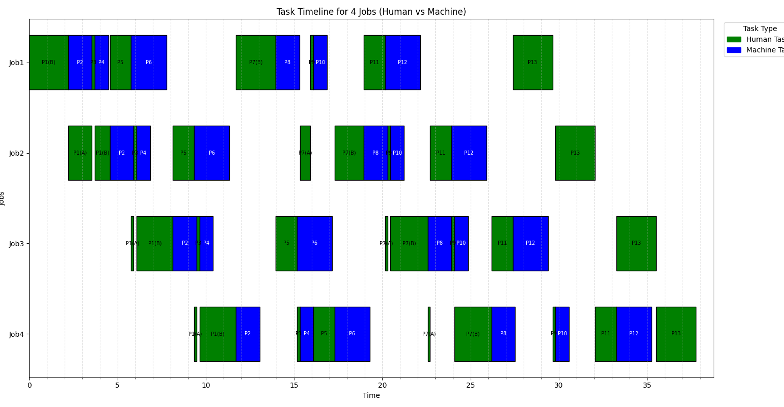

ONE WORKER AND FIVE CLIPS(JOBS)
CMAX:47.2
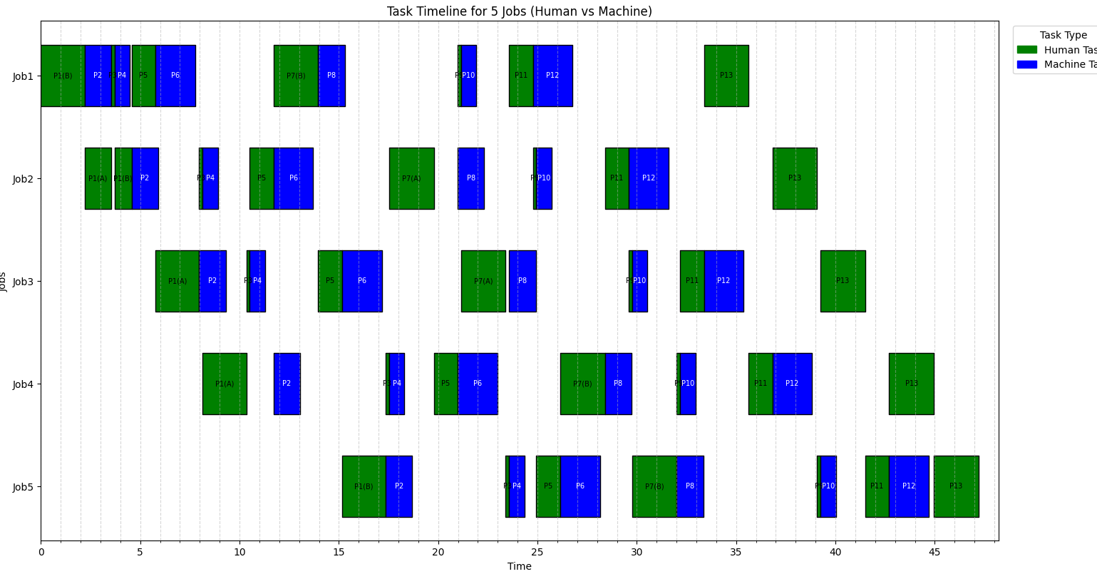

ONE WORKER AND SIX CLIPS(JOBS)
CMAX:56.63
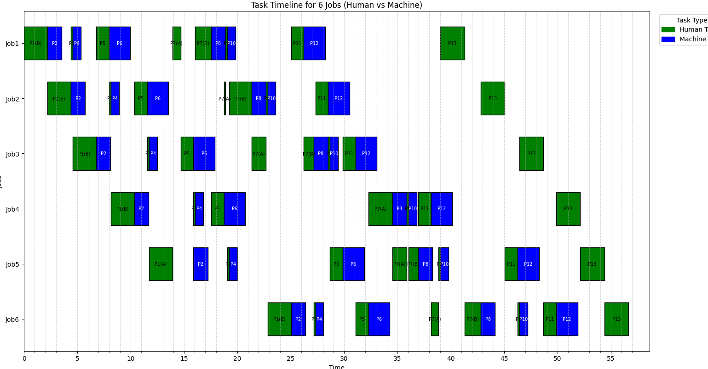

clips x and worker(one) | Cmax
1 | 17.66
2 | 20.7
3 | 29.86
4 | 37.76
5 | 47.2
6 | 56.63

Finding Optimum clips(jobs) with available resource.
clips x and worker(one) | per clip hold 500 kg | cmax | batches( 8hours per day)
1 | 250 | 17.66 | 27.18006795
2 | 500 | 20.7 | 23.1884058
3 | 750 | 29.86 | 16.07501674
4 | 1000 | 37.76 | 12.71186441
5 | 1250 | 47.2 | 10.16949153
6 | 1500 | 56.63 | 8.476072753

per hour salary for worker(18cad) | batch | output 10 percent of input | actual output
144 | 27 | 25 | 675
144 | 23 | 100 | 2300
144 | 16 | 225 | 3600
144 | 12 | 400 | 4800
144 | 10 | 625 | 6250
144 | 8 | 900 | 7200

Selling price: cad 12
Purchasing cost: cad 6

clips | purchasing cost of input | Revenue | Profit | Profit per unit
1 | 1.5 | 8.1 | 6.6 | 4.4
2 | 3 | 27.6 | 24.6 | 8.2
3 | 4.5 | 43.2 | 38.7 | 8.6
4 | 6 | 57.6 | 51.6 | 8.6
5 | 7.5 | 75 | 67.5 | 9
6 | 9 | 86.4 | 77.4 | 8.6

Based on profit per unit,5th clips is optimum.

Improvement (without increasing available resources)
Now we bring the work bech to centre .so P1 and P7 process time are 2.3 minutes and 2.2 minutes respectively.Using Button to move output one place to other with help of implement conveyor in between machines from sctuching machine to Hackler.Now processing time time for P3,P5,P9,P11 – 0.12 minutes

Tasks | Sequence | Processing time(minutes)
Workbench | P1(A) | 0
Workbench | P1(B) | 2.23
Breaker | P2 | 1.34
Button | P3 | 0.12
Sctuching machine | P4 | 0.77
Moving output to hackler | P5 | 0.12
hackler | P6 | 2
Workbench | P7(A) | 0.2
Workbench | P7(B) | 2
breaker | P8 | 1.34
Button | P9 | 0.12
Scutching machine | P10 | 0.77
Moving output to hackler | P11 | 0.12
hackler | P12 | 2
Workbench | P13 | 2.25

Our Gantt looks after improvements

ONE WORKER AND 2 CLIPS(JOBS)
CMAX:18.19
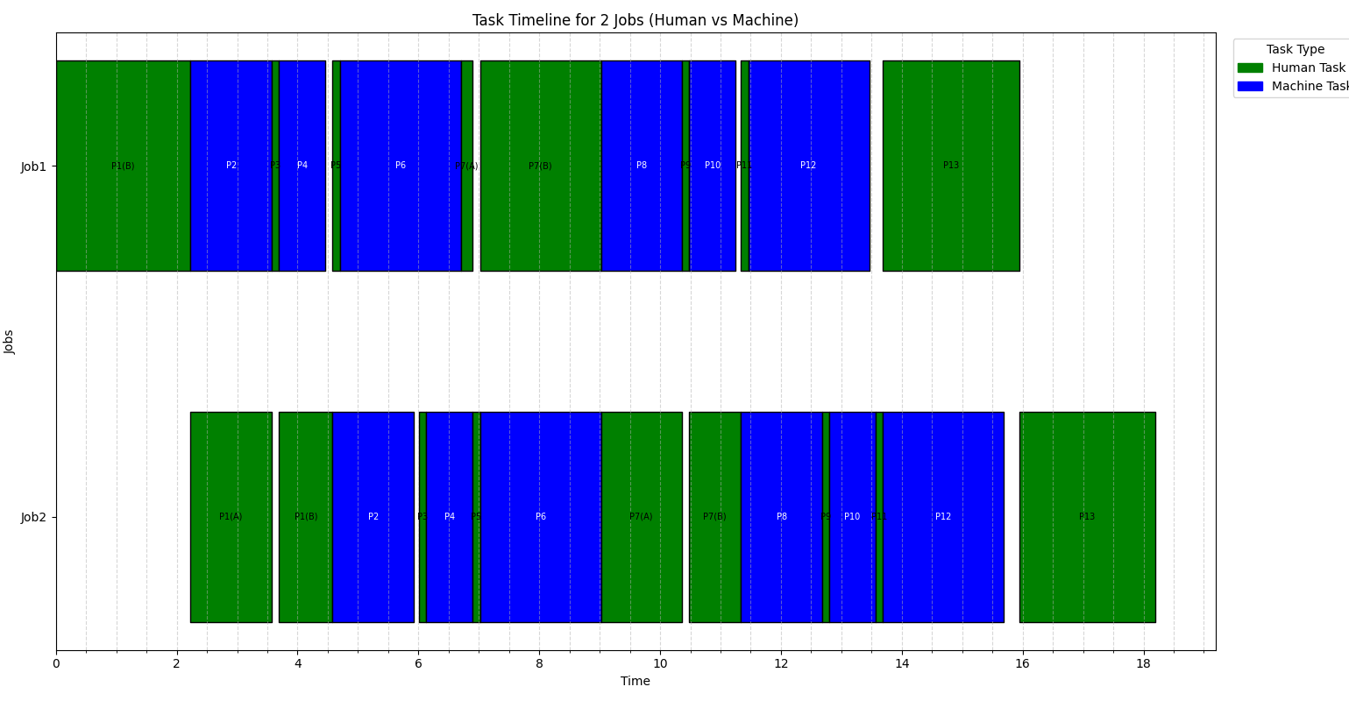

ONE WORKER AND 3 CLIPS(JOBS)
CMAX:24.09
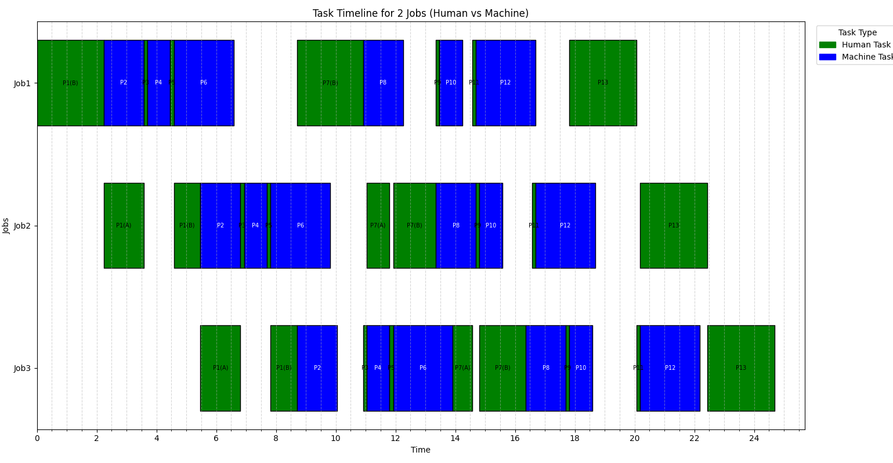

ONE WORKER AND 4 CLIPS(JOBS)
CMAX:30.09
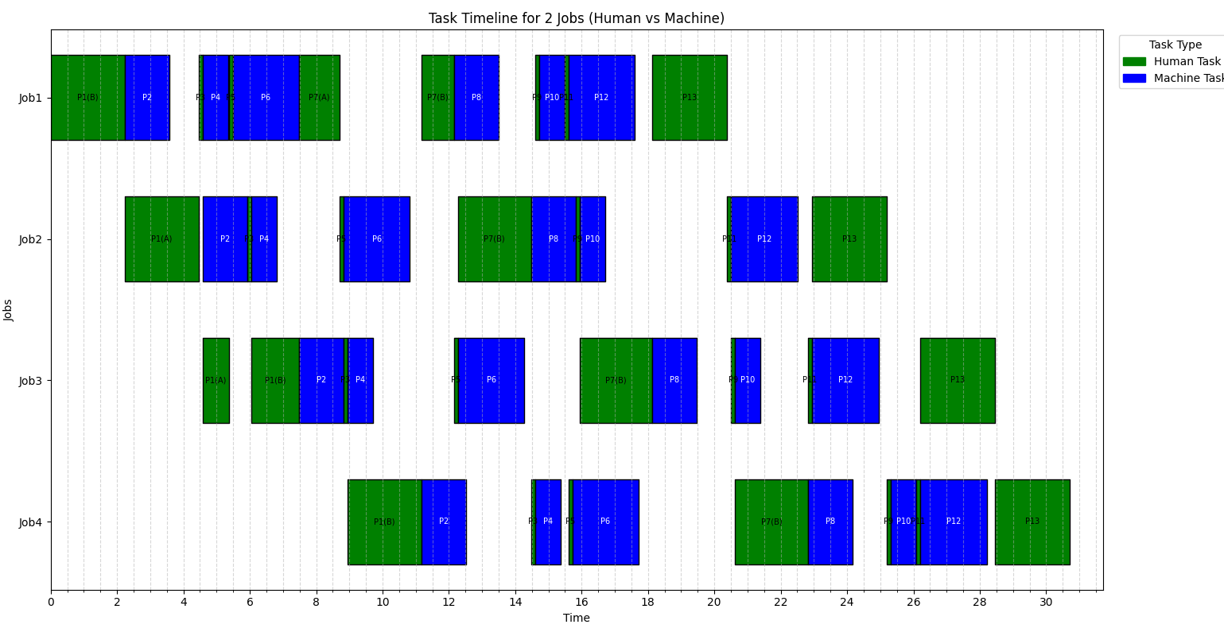

ONE WORKER AND 5 CLIPS(JOBS)
CMAX:37.02

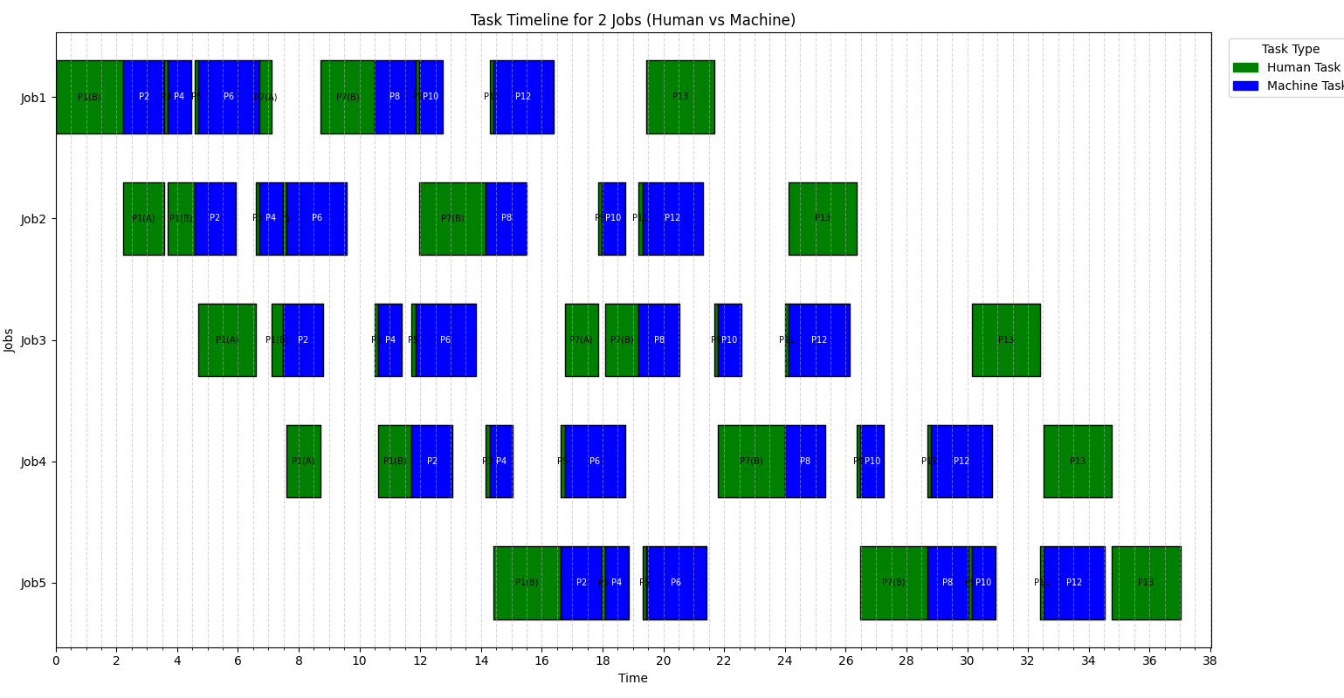

ONE WORKER AND 6 CLIPS(JOBS)
CMAX:44.83
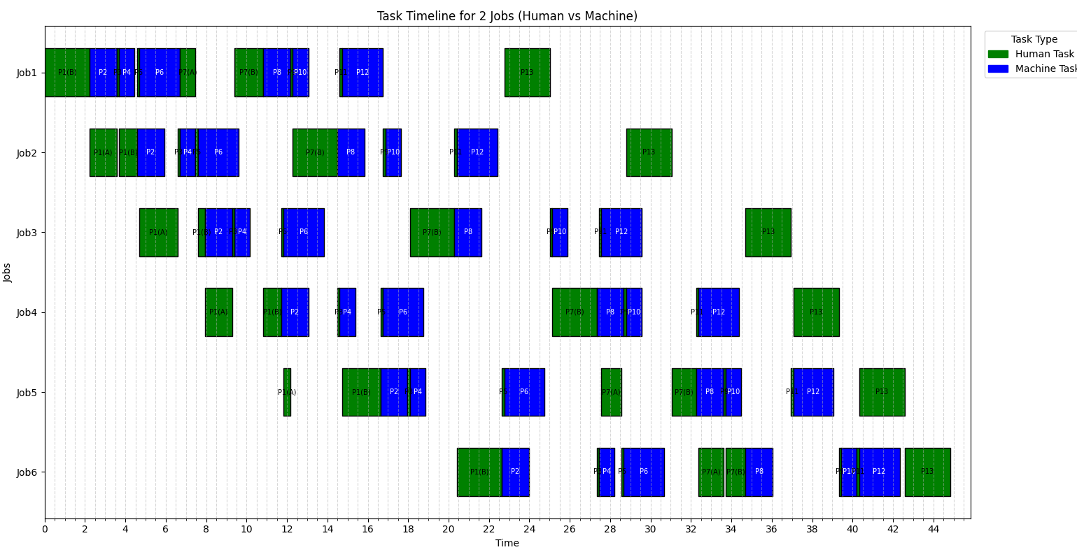
clips x and worker(one) | cmax
1 | 15.38
2 | 18.19
3 | 24.09
4 | 30.09
5 | 37.02
6 | 44.83

Finding Optimum clips(jobs) with available resource after improvements
clips x and worker(one) | per clip hold 250 kg | cmax | batches( 8hours per day) | per hour salary for worker(18cad)
1 | 250 | 15.38 | 31.20936281 | 144
2 | 500 | 18.19 | 26.38812534 | 144
3 | 750 | 24.09 | 19.9252802 | 144
4 | 1000 | 30.09 | 15.95214357 | 144
5 | 1250 | 37.02 | 12.96596434 | 144
6 | 1500 | 44.83 | 10.70711577 | 144

batch round | output=10percent of actual input | output
31 | 25 | 775
26 | 100 | 2600
19 | 225 | 4275
15 | 400 | 6000
12 | 625 | 7500
10 | 900 | 9000

Selling price: cad 12
Purchasing cost: cad 6

clips | purchasing cost of input | Revenue | Profit | Profit per unit
1 | 1.5 | 9.3 | 7.8 | 5.2
2 | 3 | 31.2 | 28.2 | 9.4
3 | 4.5 | 51.3 | 46.8 | 10.4
4 | 6 | 72 | 66 | 11
5 | 7.5 | 90 | 82.5 | 11
6 | 9 | 108 | 99 | 11

Based on profit per unit, 4 ,5 and 6 clips are optimum.

Future study and suggestion
In this project, workbench process divided into two parts to act like stop and resume in order to prioritise other jobs.In future, divide this workbench process more than 2 parts.Morover, try to increase the resource and analyse which clips are optimum.We can clearly see that after doing improvement.cmax for every clips get reduced .Trying to implement in real that help to optimize this process.

Conclusion
Using our model with available resource without doing any improvements.Doing 5 clips(jobs) is optimum.

Acknowledgement
I got help from Ai for generating python code for displaying gantt chart.

